WAN protocols

HDLC  
PPP  
Frame Relay

Wan available with two technology

1. Dedicated – lease line (costly)

* Permanent connection
* Bandwidth is fixed
* Available 24*7
* Charges are fixed whether used or not
* Uses analog circuit
* Exmp –TATA BSNL Reliance 70000-01000000 cost

1. Switched
2. Cloud
3. Packet switched----ISP they will put a router in your home (ADSL – Asymmetric digital Serial layer)
4. Circuit switched-----dial up connection –64kbps speed

Wan lease line protocols

HDLC

PPP

Frame relay

Now a days frame relay is using in old companies only.

HDLC – high level data link control protocol

1. Hdlc is not support authentication.
2. Hdlc is by default configured
3. Hdlc is faster than ppp.

Take two router—connect them with serial DCE cable---make first router as DC---DC means give clock rate in that router.

Give ip addresses for both serial interfaces

Ping them with each other. (but clock rate is not necessary in latest cisco packet tracer)

Now check properties of serial interface

# show interface serial0/0/0

Check encapsulation there -----you will HDLC protocol there

Means packets traffic are going through the HDLC.

Go to simulation mode check it

If you want to change hdlc to ppp

Then go to CLI open interface mode

Enter # encapsulation ?

It will show 3 wan protocols

So

# enacapsulation ppp enter

If you changed to ppp then on other router connection will become down so you have change hdlc to ppp on second router also.

PPP

It uses two protocols

1. LCP

Link control protocol

* Take care of setting up link

1. NCP

Network control protocol

Makes sure you can run multiple protocols

We can send ip and protocols across ppp link.

PPP supports two authentication protocols

1. PAP--- password authentication protocols
2. CHAP- Challenge hand shake authentication protocol

(in mobile you will do pap and chap settings) dial up connection

1. PAP

Simple one

Two way hand shake protocols

It will check password on both side—if password not matched then it rejects the connection.

PAP is not strong

PAP is done only when initial link established

1. CHAP

It uses MD(message Digest)5 encryption

That means you will find enable password and secret password.

You can break enable password but not enable secret coz it uses MD5 encryption.

Enable CHAP

# interface ser 0/0/0

# encapsulation ppp

#Ppp authentication chap

Do same on both side

After that you have to give password

# hostname r1 and r2

Now on r2

Create username means hostname of other router

#username r1 password cisco

Same on r

#username r2 password cisco

Now they know each other becoz same password.

Go to simulation mode ----ping it---open packet

Enable PAP

#encapsulation ppp

#ppp authentication pap

#ppp pap sent username r1 password cisco

In pap create username on one side and sent it to other.

Frame relay protocol

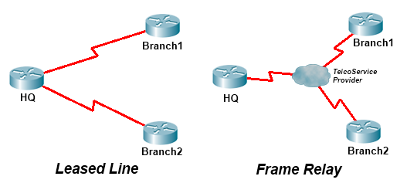

Frame relay is low cost

Frame relay cloud

Ease of management

Internal work in frame relay

Virtual circuit

Connection in frame relay are provided by virtual circuits.

Multiple logical connections on same physical connection.

Range 16-1007